A Deep Dive on LIME for Local Interpretations

The intuition, theory, and code for Local Interpretable Model-agnostic Explanations (LIME)
LIME is the OG of XAI methods. It allows us to understand how machine learning models work. Specifically, it can help us understand how individual predictions are made (i.e. local interpretations).
Although recent advancements means LIME is less popular, it is still worth understanding. This is because it is a relatively simple approach and is “good enough” for many interpretability problems. It is also the inspiration for a more recent local interpretability method — SHAP.
So we will:
- Discuss the steps taken by LIME to get local interpretations.
- Discuss in detail some of your choices related to these steps including how to weight samples and which surrogate model to use.
- Apply the lime Python package.
Along the way, we will compare the method to SHAP. This is to better understand its weaknesses. We will also see that, although LIME is a local method, we can still aggregate lime weights to get global interpretations. Doing so will help us understand some of the default choices made by the package.

The LIME algorithm
Machine learning models are complex functions. The idea behind LIME is that this complexity falls away if we zoom into the feature space in the area around an instance. The function is much simpler or even linear. This allows us to understand how predictions are made in this area by building simple models on permutations of the instance.
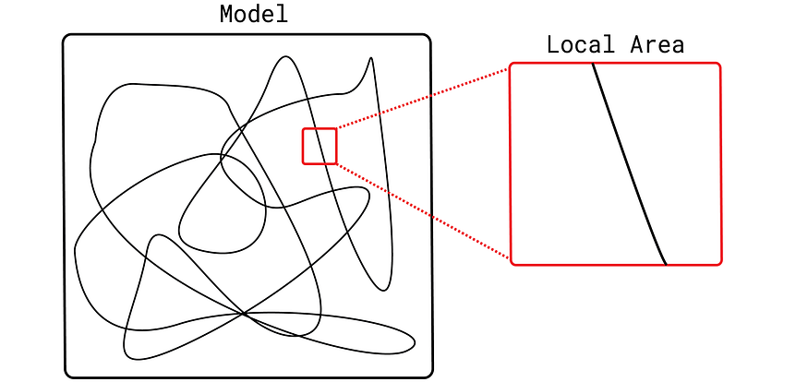
Complexed machine learning model
These simple models are known as surrogate models. These must be intrinsically interpretable models like decision trees or linear regression. This is important as we can understand how these models work by looking directly at their structure or parameters.
Now, there is a lot of choice around how we build such a surrogate model. We discuss the most important ones below. First, let’s summarise the steps taken by the LIME algorithm:
- Select the instance you want to explain
- Generate samples by permuting feature values
- Assign a weight to each of the samples based on how far they are from the instance
- Make predictions on these permutations using the original black-box model
- Train a surrogate model using the weighted samples and predictions as the target variable
- Interpret the surrogate model
The result is a simple surrogate model trained on an individual instance. By interpreting this model, we can understand how the original black-box model made the prediction for that instance. A key benefit is this is done in a model-agnostic way. As we only consider the black-box model predictions, we can apply this method to any machine learning algorithm.

Permuting feature values
Permutations are important for many XAI methods. However, LIME uses a different approach to Permutation Feature Importance, PDPs or ALEs. That is:
- For continuous features, we sample from a normal distribution with the same mean and standard deviation of the feature.
- For categorical features, we randomly select categories based on the proportions observed in the training data.
Importantly, this will give us feature values that are similar to those the black-box model was trained on. It also gives us flexibility over how many samples we can create. By default, it is set to 5000 in the LIME package. This is usually enough to train models like linear regression.

Weighting samples
The above process will generate samples across the entire feature space. Yet, we are interested in how the model behaves around an instance. This is why we need to weight the samples based on their distance from the instance. To do this, LIME uses the Gaussian kernel:

Gaussian kernel
Here x is the instance being explained and x’ is the sample we want to weight. ||x — x’|| is the Euclidean distance of the normalized feature values. For categorical features, the one-hot encodings of the features are used to calculate the distance. σ² is known as the kernel width. It controls how quickly the weights assigned to perturbed samples decrease with increasing distance from the instance being explained.
By default, the kernel width is set to 0.75*sqrt(number of features). We can change this value but it is not clear what value will be best for a given problem. As seen in Figure 1, if we set σ² too small then only samples very close to the instance will receive significant weights. As a result, we will not capture enough variation in the feature values to understand how they impact the prediction. Too large and the relationships are no longer linear.
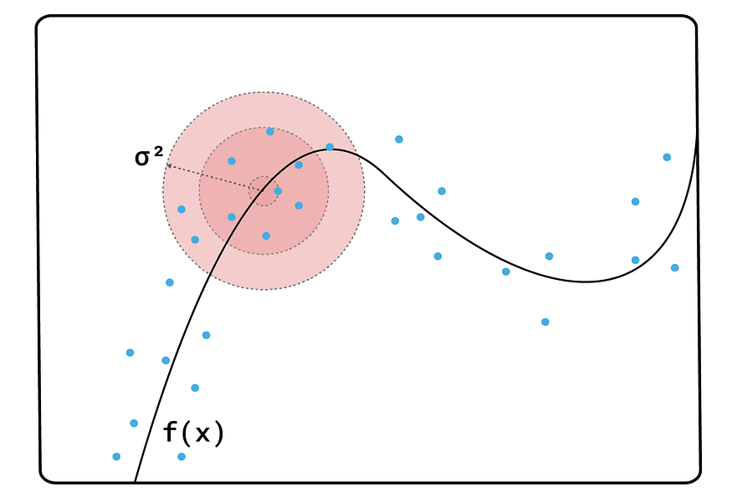
Figure 1: abstract representation of how changes in the kernel width may skew local interpretations. The blue dots give the perturbed samples

Number of features
We do not need to train our surrogate model on all of the features used by the black-box model. Linear surrogate models in particular can only handle a limited number. We can decide on the number of features used in the explanation and its default is a maximum of 10. If we select a number less than the number of original features, we will also need to choose a selection algorithm (e.g. forward selection).

Discretization
Another choice around continuous features is whether to group them into categories based on their quantiles or deciles. This is known as discretization. We will see when applying the lime package that, by default, all numerical features will be grouped by their quantiles. This is to make it easier to provide explanations for these features.

The surrogate model
Finally, we have the choice of what model we use for our surrogate model. The default is ridge regression but we can use other types of linear regression or even a decision tree. Keep in mind that the model must be inherently interpretable. For linear models, the coefficients for each feature tell us how the feature has contributed to the prediction we want to explain.
Initially, all of these choices may seem like a good thing. However, it leads to LIME’s biggest weakness — inconsistent explanations. The flexibility opens us up to a form of P-hacking as we can manipulate the variables until we get the explanations we want. For those without good domain knowledge, it may also be difficult to tell if an explanation is reasonable.
LIME is also not “consistent”. This means if we adjust a model so the relationship with a feature changes the LIME weights will not necessarily change in a way that reflects this. For example, suppose we change a model from M1 to M2. A feature may now increase a prediction more than before. However, we will not necessarily be able to tell this using LIME.
Countering these weaknesses is one of the reasons why SHAP is so popular. This method is based on the theory behind Shapley Values. This leads to some desirable properties for a local interpretability method. SHAP values are inherently consistent. It is also harder to manipulate results as there is also no flexibility in how Shapley Values are calculated.

The Math / Formula
The video breaks down the optimization function used by LIME: argmin_{g€G} L(f,g,π_{x}) + Ω(g)
- L(f,g,π_{x}): Measures the difference between the complex model f and the simple model g within the local neighborhood π_{x}.
- π_{x}: A proximity measure (often an exponential kernel) that weights nearby data points more heavily.
- Ω(g): A complexity measure that enforces simplicity (e.g., using sparse linear models with few features).

Applications with the lime package
We start with imports for this project. As we are working with tabular data, we use the LimeTabularExplainer function (line 7).
# Imports
import pandas as pd
import numpy as np
import matplotlib.pyplot as plt
%matplotlib inline
from sklearn.ensemble import RandomForestRegressor
from lime.lime_tabular import LimeTabularExplainer

Data and model
We will use the abalone dataset (CC BY 4.0). Abalone is a shellfish delicacy. We want to predict the number of rings in their shell using features like shell weight and shucked weight (weight of the meat).
We load the dataset (lines 2–4) and select the target (line 6). We also do some feature engineering. First, we exclude some highly correlated features (line 7). This is because they have a correlation of 1 with the other features. Finally, we create one-hot-encodings for the sex feature (lines 10–13). You can see a snapshot of the final feature set in Figure 2. We have 8 features in total.
#import dataset
data = pd.read_csv("../../data/abalone.data",
names=["sex","length","diameter","height","whole weight",
"shucked weight","viscera weight","shell weight","rings"])
y = data["rings"]
X = data[["sex", "length", "height", "shucked weight", "viscera weight", "shell weight"]]
# Create dummy variables
X['sex.M'] = [1 if s == 'M' else 0 for s in X['sex']]
X['sex.F'] = [1 if s == 'F' else 0 for s in X['sex']]
X['sex.I'] = [1 if s == 'I' else 0 for s in X['sex']]
X = X.drop('sex', axis=1)
X.head()
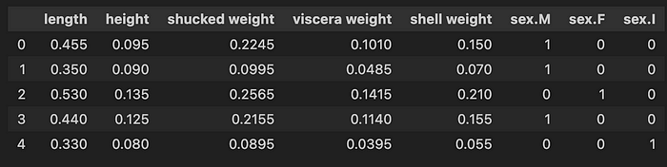
Figure 2: snapshot of abalone features
We use these features to train a model to predict the number of rings (lines 2–3). In this case, we have used a random forest. However, keep in mind that the LIME is model agnostic. This means you should be able to apply it with most modelling packages.
# Train model
model = RandomForestRegressor()
model.fit(X, y)

Local explanations
To create local explanations, we start by creating a LIME explainer (lines 2–6). We pass in our X feature matrix, feature names and target variable names. We let the package know we have a regression model (line 5) and we set the random state (line 6) so that we get the same results for each new run.
# Create the explainer
explainer = LimeTabularExplainer(X.values,
feature_names=X.columns,
class_names=['rings'],
mode='regression',
random_state=101)
We then use this explainer to create an explainer object, exp, for our first prediction (lines 2–4). Finally, we display this explainer object (line 7). The output of this is what you see in Figure 3. By setting table=True we include the table on the right. We haven’t set parameters for choices like the kernel width or surrogate model so the package will use the default values.
# Get explanation for first row
exp = explainer.explain_instance(X.iloc[0],
model.predict,
labels=X.columns)
#Display explanation
exp.show_in_notebook(show_table=True)
Figure 3, gives us a lot of information about the first prediction. We can see the predicted value was 12.98 rings. The chart in the middle tells us how each feature has contributed to the prediction. Notice there are 8 bars — one for each feature. For example, for this abalone, the value for shell weight has decreased the number of predicted rings. The value, -1.20, is the LIME weight for this feature. The table on the right gives the feature values.
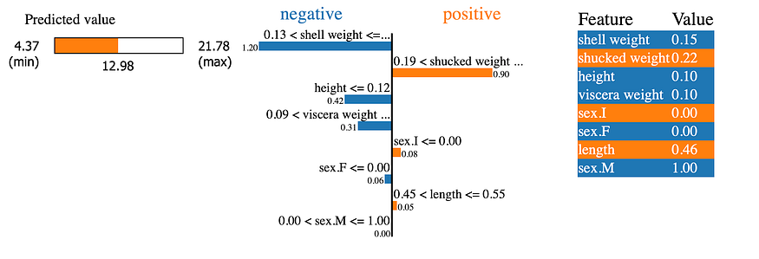
Figure 3: LIME explanation for the first prediction
The LIME weights for each feature are the coefficients of the surrogate model. Unlike SHAP, the sum of the weights and the mean prediction will not equal the prediction for the given instance. You can confirm this using the code below. This is because LIME is not “efficient”.
# Check calculations
exp_weight = [x[1] for x in exp.as_map()[1]]
print(np.mean(y_pred) + sum(exp_weight)) #9.64
print(y_pred[0]) #12.68
This property is another advantage of SHAP. That is if you add the SHAP values for each model feature and the average prediction you get the prediction for the instance. In other words, they tell us exactly how much a feature has changed the prediction. This improves the interpretation of SHAP values. With LIME, we only know the direction and the importance.

Squeezing more out of LIME (global interpretations)
Local explanations are great when you want to understand how individual predictions are made. However, looking at a single prediction won’t tell us how the model works in general. To do that, we can use different aggregations of local explanations. That is we will combine the LIME weights of many predictions using different charts.
To start, we need to get the LIME weights from our explainer objects. To do this, we can use the function, return_weights, below. This function accepts an explainer object, exp. From this object, it will get and return a list of LIME weights, exp_weight. These weights will be ordered in the same order as the features in the X feature matrix.
def return_weights(exp):
"""Get weights from LIME explanation object"""
exp_list = exp.as_map()[1]
exp_list = sorted(exp_list, key=lambda x: x[0])
exp_weight = [x[1] for x in exp_list]
return exp_weight
To use this function, we will iterate over the first 100 rows in our X feature matrix (line 4). For each iteration, we will create an explanation object (lines 7–10). We get the weights from this object using the return_weights function (line 13) and append them to a list of weights (line 14). Lastly, we create the DataFrame, lime_weights, using this list of weights (line 17).
weights = []
# Iterate over first 100 rows in feature matrix
for x in X.values[0:100]:
# Get explanation
exp = explainer.explain_instance(x,
model.predict,
num_features=10,
labels=X.columns)
# Get weights
exp_weight = return_weights(exp)
weights.append(exp_weight)
# Create DataFrame
lime_weights = pd.DataFrame(data=weights,columns=X.columns)
The lime_weights dataset has the shape (100,8). Each row represents a different prediction. For each prediction, there is a LIME weight for each of the 8 features. We can now use this dataset to create global aggregations of the LIME weights.

Absolute Mean
The first aggregation can help us understand which of the features are most important. Features with either high positive or negative LIME weights had a larger impact on a prediction. For each feature, we can take the absolute mean of all the LIME weights. Features with large mean weights have, in general, made large contributions to the predictions.
We can see the mean weights for our model in Figure 4. Notice how shell weight and shucked weight have larger mean weights in comparison to the other features. This tells us that these features are the most important when it comes to predicting the number of rings.
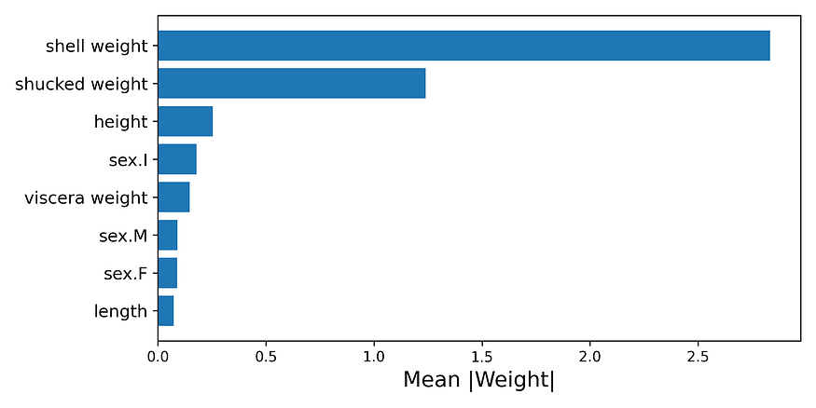
Figure 4: absolute mean of LIME weights
To create this chart, we start by taking the absolute mean of the weights (line 2). We then create a new DataFrame with two columns — the feature name and absolute mean (line 3). We order this DataFrame from the largest to smallest mean weight (line 4). Finally, we plot a bar chart using this DataFrame (line 9–11).
# Get abs mean of LIME weights
abs_mean = lime_weights.abs().mean(axis=0)
abs_mean = pd.DataFrame(data={'feature':abs_mean.index, 'abs_mean':abs_mean})
abs_mean = abs_mean.sort_values('abs_mean')
# Plot abs mean
fig, ax = plt.subplots(nrows=1, ncols=1,figsize=(8,4))
y_ticks = range(len(abs_mean))
y_labels = abs_mean.feature
plt.barh(y=y_ticks,width=abs_mean.abs_mean,)
plt.yticks(ticks=y_ticks,labels=y_labels,size= 12)
plt.title('')
plt.ylabel('')
plt.xlabel('Mean |Weight|',size=15)

Feature Trend
We can also look at the trend for one of the model features — whole weight. This is the weight of the entire abalone. In Figure 5, we can see that as whole weight increases the LIME weight increases. A higher LIME weight indicates that, for a specific prediction, the feature value has increased the predicted number of rings. So, this chart tells us that as the weight of the abalone increases the number of rings in its shell tends to increase. This makes sense as we would expect older abalone to be larger/heavier.
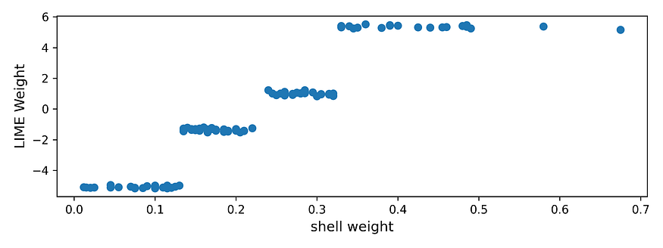
Figure 5: feature trend for whole weight
To create this chart, we first get the LIME weights for the whole weight feature (line 4). We also get the corresponding feature values (line 5). Then we create a scatterplot of the weights and feature values (line 7).
fig, ax = plt.subplots(nrows=1, ncols=1,figsize=(8,3))
# Get weights and feature values
feature_weigth = lime_weights['shell weight']
feature_value = X['shell weight'][0:100]
plt.scatter(x=feature_value ,y=feature_weigth)
plt.ylabel('LIME Weight',size=12)
plt.xlabel('shell weight',size=12)

Beeswarm
Our final aggregation is a beeswarm plot. As seen in Figure 6, this is a plot of all the LIME weights. The values are grouped by the features on the y-axis. For each group, the colour of the points is determined by the value of the same feature (i.e. higher feature values are red). The features are ordered by the mean LIME weights.
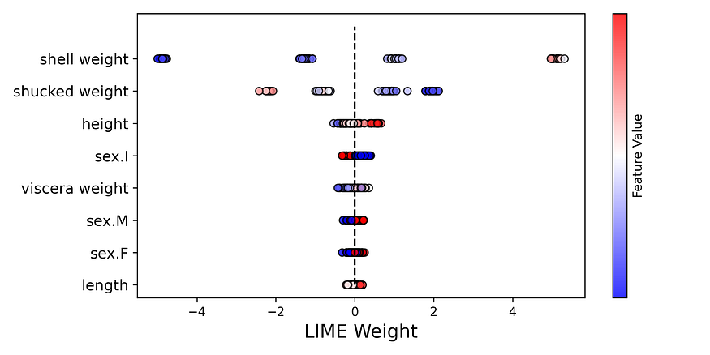
Figure 6: beeswarm of LIME weights
To create this chart we use the code below. To give an overview, we iterate over each of the features (line 8). For each of the features, we get the weights and values (lines 10–11). Using these, we then create a scatterplot (lines 13–18). The trick is to set the y-value for each of the points to the same value (line 14). This is how we get each point of the scatterplots on a straight line.
fig, ax = plt.subplots(nrows=1, ncols=1,figsize=(8,4))
y_ticks = range(len(abs_mean))
y_labels = abs_mean.feature
# Plot scatterplot for each feature
for i,feature in enumerate(y_labels):
feature_weigth = lime_weights[feature]
feature_value = X[feature][0:100]
plt.scatter(x=feature_weigth ,
y=[i]*len(feature_weigth),
c=feature_value,
cmap='bwr',
edgecolors='black',
alpha=0.8)
plt.vlines(x=0,ymin=0,ymax=len(y_labels),colors='black',linestyles="--")
plt.colorbar(label='Feature Value',ticks=[])
plt.yticks(ticks=y_ticks,labels=y_labels,size=12)
plt.xlabel('LIME Weight',size=15)
If you are familiar with the SHAP package, you will recognise these plots. The ease of use and deep insight these plots provide is another reason SHAP is so popular. Throughout the article, we also explained how the theory behind SHAP leads to desirable properties. Ultimately, the package is easier to use and provides more reliable local interpretations than LIME.
Still LIME can be useful. There are many low-stakes applications where the consistency of explanations is not that important. Also, as we saw, the theory is fairly straightforward. The idea of building linear models on individual predictions of a complex model may not be that difficult to explain. It will certainly be easier than explaining the theory behind SHAP.
We also mentioned that SHAP was inspired by LIME. This is because SHAP estimates Shapley values using linear models built on an individual prediction. In this sense, SHAP can be seen as a special case of LIME where the model weights are Shapley Values. This is achieved using a specific kernel. Ultimately, understanding LIME can help you understand SHAP.

